2002/2004 Infiniti Q45 Informal User's Guide
to the Self Diagnosis Displays

September 2, 2003

DISCLAIMERS

The following descriptions are provided on an "as-is" basis. This is not an official document and has not been produced by the Infiniti Division of Nissan North America.

The displays discussed below are meant for servicing the 2002/2004 Q45 and were not meant for the use of the average consumer. Some of the displays can result in changes to the vehicle's calibration data and should not be used without understanding the results. While some of the displays can be enabled while driving, some jurisdictions do not permit these types of displays to be used while driving.

Use this document and the displays discussed below at your own risk. The only person responsible for any damage that results from the use of the information in this document is the user of the information. If any of the above information is disseminated (even to the commissioner of baseball), please provide the above warnings, as well.

This unofficial document should be used as an extension of the official 2002/2004 Q45 Owners Manual. Consult the owner's manual for trademark, service mark, patent and copyright information.

INTRODUCTION

The following pages contain descriptions and images available on the 2002/2003 Q45 for diagnosis and correcting problems with the Q45's various body control systems. The descriptions are an attempt to help the user successfully navigate these displays. Where options are known they are also documented.

The document is written in a top-down manner. The highest level display is described first, then the next level display until the bottom level display is reached.

Throughout the document, the term "soft-key" and "hard-key" are used. A soft-key is a button which appears on a display. To activate a soft-key, use the joystick/enter combination of keys. A hard-key is a physical button which appears on the dash and can be activated by pressing the button.
Accessing the Body Control Module "SELF DIAGNOSIS" display (i.e.: How to Start)

- Start the car
- Press "OFF" Button on the Audio System (Voice command can be substituted)
- With audio off, press and hold INFO button - "Vehicle Information" Menu Display should appear.
- While holding the "INFO" button, rock/rotate the Audio Volume ring outside of the "AUDIO" button
Note : Rocking motion must be at least 20 degrees in each direction
- After rocking the outer ring 4-6 times the "SELF DIAGNOSIS" display will appear.

At this point the user has entered the diagnostic display system. In order to exit the system, use the "PREV" key (or "Previous Display" voice key) until the system returns to the normal displays. Shutting off the ignition will also terminate the diagnostic display system.

When returning from the diagnostic display system, the car will be in the Dual Display mode (ie Audio and Climate control information shown on the display). To return to the navigation system, simply hit the "MAP" hard-key.

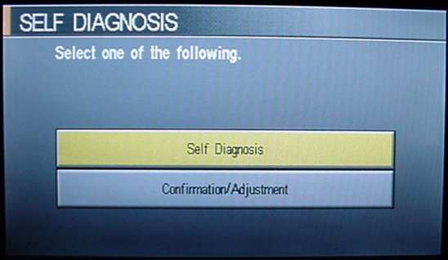
SELF DIAGNOSIS Display:

This menu allows other diagnostic menu options to be selected.

- The SELF DIAGNOSIS Display consists of two options. The "Self Diagnosis" menu selection and the "Confirmation/Adjustment" menu selection. Use the standard joystick/enter combination to select the desired option.
- Use the "PREV" button from the SELF DIAGNOSIS display to return to "standard" Q45 displays.
Note : Voice commands are disabled in this menu.

SELF DIAGNOSIS Activation:

This menu activates a self-test routine and then displays the results of the tests. This test cannot be run while the car is in motion.

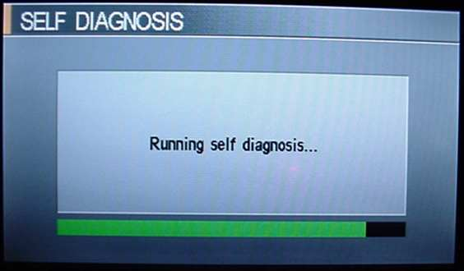
- Pressing the "Self Diagnosis" menu option from the SELF DIAGNOSIS display will cause the car to run a check of the various body systems.
- Upon completion of the Built-In Test, a menu showing the results of the tests will be shown. On the menu will be the following items:

- Multifunction Switch
- Display
- Audio AMP
- Center Control Unit
- Audio Unit
- Voice Activated Control Module
- Tire Pressure Control Unit
- Rearview Camera Control Unit
- GPS Antenna
- CD Changer

A Green soft-light will be shown next to the component if the component passed the tests successfully. A different color will be shown otherwise.

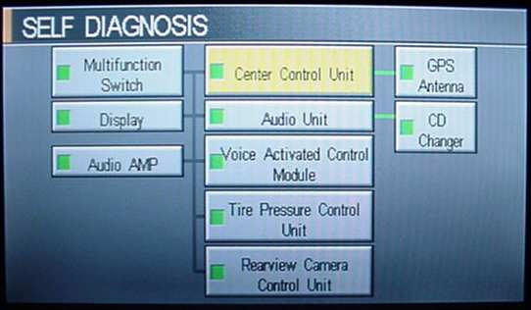
Selecting any of the components using the joystick/enter combination results in the display of a report on any errors found. If no errors are found, a standard message is displayed saying that no errors were found and to consult the service manual for further information.
CONFIRMATION/ADJUSTMENT Display:

This menu allows the user to select various components for further testing, analysis or adjustment. This menu can be used while the car is in motion.

- Upon selection of the "Confirmation/Adjustment" option from the SELF DIAGNOSIS Display, the "Confirmation/Adjustment" Display is shown. On the display, the following options are shown:

- Display Diagnosis
- Vehicle Signals
- History of Errors
- Rearview
- Navigation
- Auto Climate Control
- Speaker Test
- Voice Mic. Test

- Use the joystick/enter combination to select the various menu options. All of the options, with the exception of the "Voice Mic. Test", generate a sub-menu display.

Note : Voice commands are available with this menu and the sub-menus.

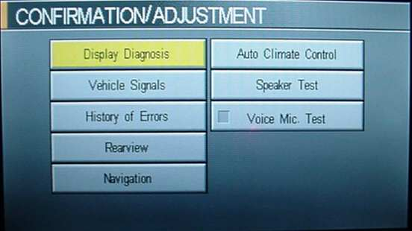
DISPLAY DIAGNOSIS Display:

- This display is activated from the "Confirmation/Adjustment" display.
- The display shows the following options used to calibrate the color/tint and brightness/contrast options for the main LCD display: Use the Joystick/Enter combination to select the appropriate display.
- Display Color Spectrum Bar - Shows standard color spectrum.
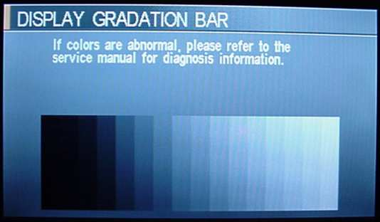
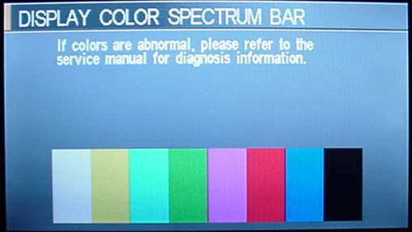
- Display Gradation Bar - Shows gray level calibration display for brightness/contrast adjustment.
VEHICLE SIGNALS Display:

- Vehicle Speed - (On/Off) - Indicates if vehicle is moving for lawyer-enabled protections.
- Parking Brake - (On/Off) - Indicates if the parking brakes is enabled or disabled.
- Light - (On/Off) - Indicates if the Xenon headlights are on or off.
- IGN - (On/Off) - Indicates if the engine is on or off.
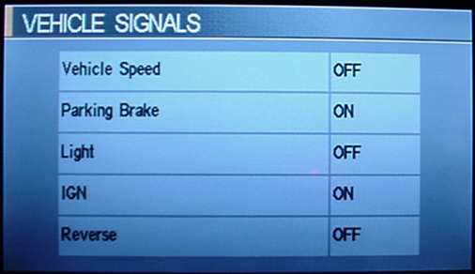
- Reverse - (On/Off) - Indicates if the gear shifter is set to reverse.

HISTORY OF ERRORS Display:

This display is used as a Fault Summary display. The display will likely show a vertical green bar with no faults. A "Delete" soft-key will be visible in the upper right corner.

- Faulty component and number of errors occurred - Shows a history of what components have failed. For each failed component, the display also indicates the number of errors detected.
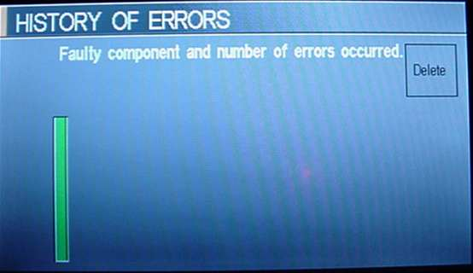
- Delete - Deletes selected error.

REARVIEW Display:

This display shows the view from the rear view camera. The camera view remains enabled at all times while in this display. The display allows the distance line gradations to be moved to align the markers with the camera position. Failure to properly calibrate can result in the lines not matching the specifications shown in the Q45 owners manual.

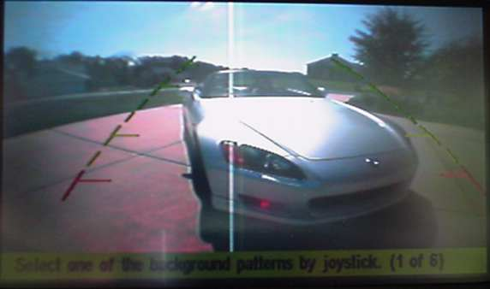
- Select one of the background patterns by joystick (1 of 6) - Selects position of the distance lines.
NAVIGATION Display:

Allows the Global Positioning Satellite (GPS) system and Inertial Navigation System (INS) settings to be changed. This allows the initial values for the navigation system to be specified.

- Display Longitude & Lattitude - Shows map and allows the car position to be moved relative to the current map position.
- Speed Calibration - Allows the interpolated speed from the wheel's speed sensors to be adjusted to be faster or slower.
- Angle Adjustment - Allows the starting car angle to be changed. Changes this value allows the INS and mapping software to determine turn radius when mapping.
- 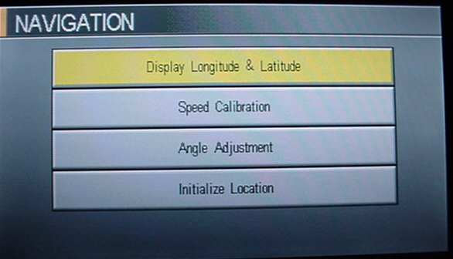Initialize Location - Appears to return the GPS to its starting point in Los Angeles, California.
AUTO CLIMARY CONTROL Display:

This very strange display results in the climate control being disabled and the following displayed:

- -188 degrees F
- Dual On
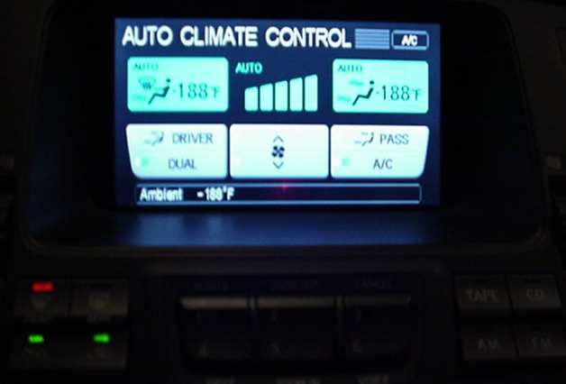
- AC On

SPEAKER TEST Display:

This display allows for testing of individual speakers within the Q45. Eight of the eight speakers are testable. The Subwoofer is also available for individual testing.

To activate the test, select the "Start/Next" button with the joystick/enter combination. The tweeters are tested with 1kHz tones, while the midrange is tested with a 500Hz tone. Levels are fairly loud and do not appear to be adjustable.

Each time the "Start/Next" button in pressed, the next speaker (clockwise direction) on the display is selected. Pressing the "Stop" button stops the testing.

The following speakers are displayed:

- FL - Front left tweeter
- FC - Front center tweeter
- FR - Front right tweeter
- FDR - Front right door midrange
- RDR - Rear right door midrange
- FCW - Rear center SubWoofer
- RDL - Rear left door midrange
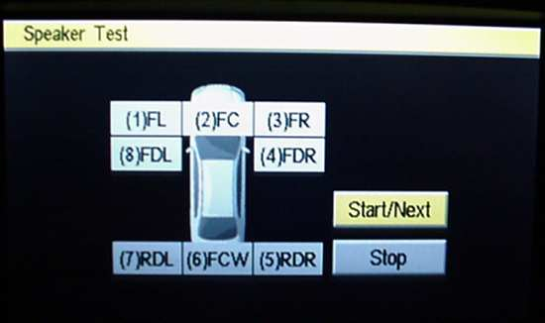
- FDL - Front left door midrange
VOICE/MIC. TEST Activation:

Selecting this option activates the front omnidirectional microphone, the vehicle speakers and places a green soft-light next to the option. The likely result of all this is feedback if the system is properly working.

- This option is activated from the "Confirmation/Adjustment" display.
- To enable/disable this option, use the joystick/enter combination to click on the option. No sub-menu is displayed.

FINAL NOTES:

It is hoped that additional display information will follow when these displays are found…

This document was written by Andy K. and edited by Jason B., who also provided the photos. Jason’s 2002 Q45 website can be found here: http://get.to/q45. Both individuals are luckily not affiliated with the Infiniti Division of Nissan North America in any way, shape or form.

Any corrections to the information contained within will be gladly accepted.

